LINUX

1. Download the file [web_scraper.sh](https://hs2solutions-my.sharepoint.com/:u:/g/personal/sharath_ram_bounteous_com/EVjtybZVxKRHjRNAwDkxVIYB_IKgcXaEGaAEjgcYAnTC1Q?e=MwOOxC) . Make the file executable. The file takes any wikipedia webpage as an argument. Run the process on multiple sites like

[Wikipedia:Stub - Wikipedia](https://en.wikipedia.org/wiki/Wikipedia:Stub) , [India - Wikipedia](https://en.wikipedia.org/wiki/India) at the same time and

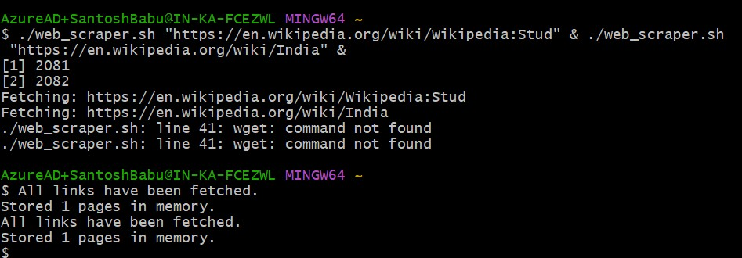

1. Find all the processes running on the system.

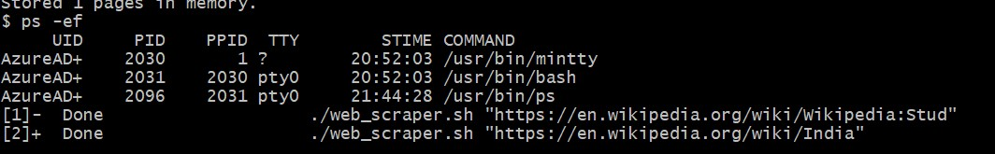

1. Print the HTTP response code obtained from google.com.

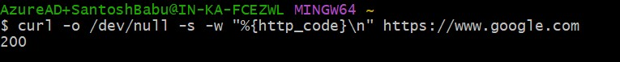

1. Find the top 3 running processes which consume the most processing power.



1. Write a script that finds all files larger than 100MB in a directory and lists them.



1. Find which version of Python is installed on the system.



Find which version of java is installed on the system

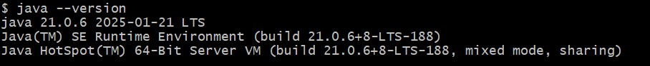

1. Get the current time zone of your system.



1. Find current time in New York, London.

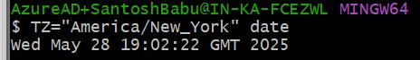

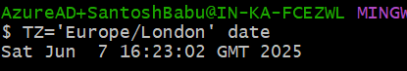

1. Check for how long the system is up.



11. Given a log file:

a. Find all the errors in the log and dump them to a new file.

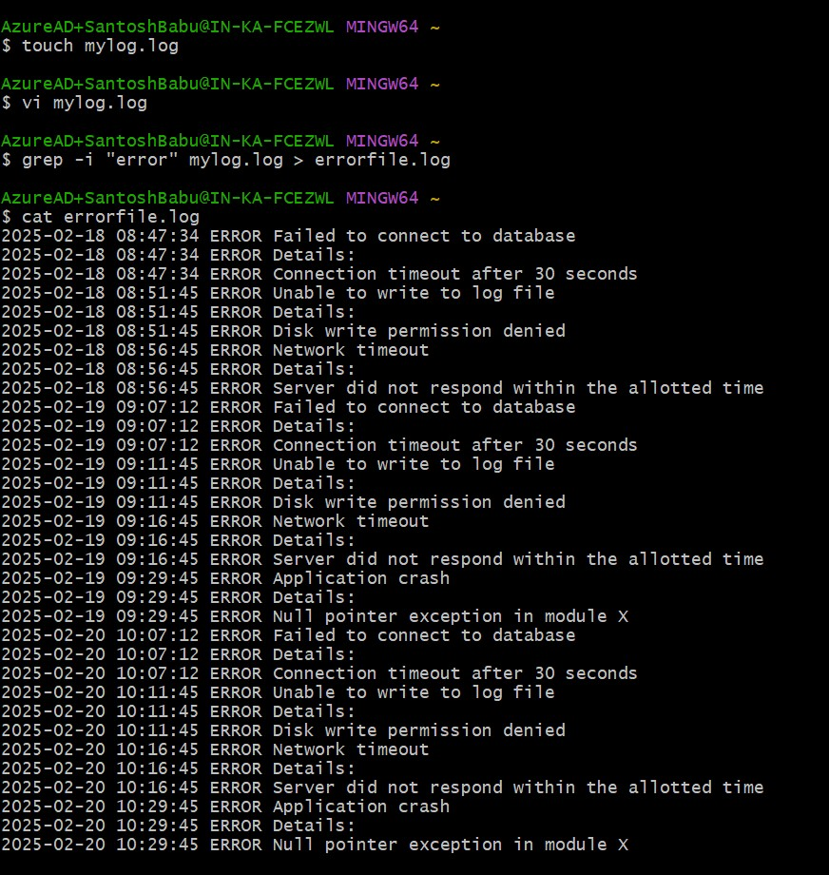

1. What events occurred between 09:10 and 09:19?

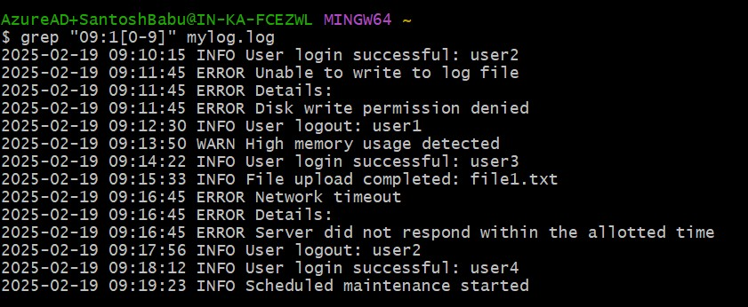

1. How many INFO messages are in the log file?

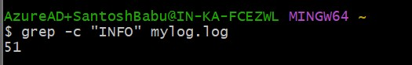

1. Print the first 5 lines of the file.

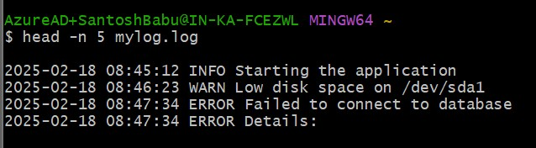

1. Print the last 5 lines of the file.

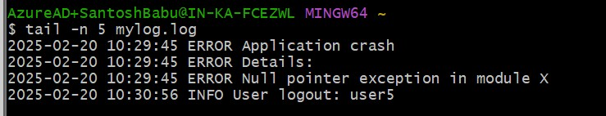

1. Print lines if the lines contain error, fail, or warning.

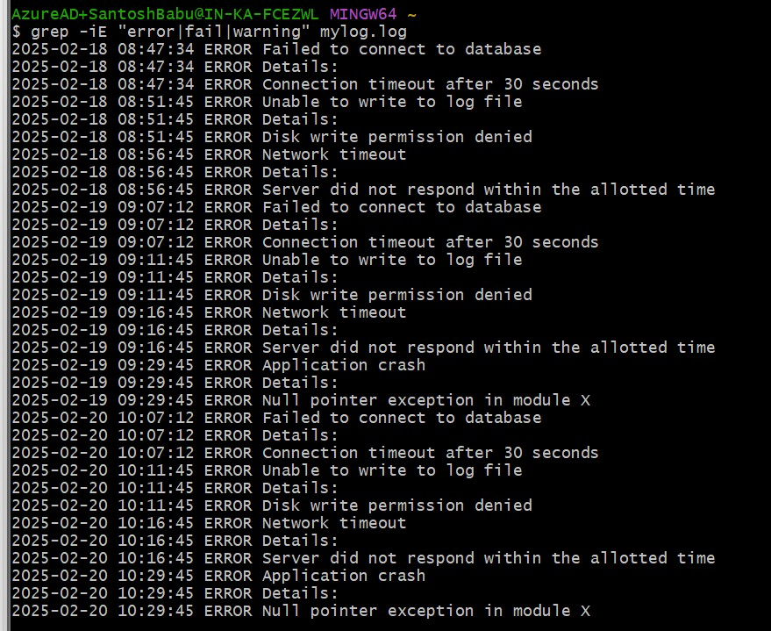

1. Rename the file to new_log.log.

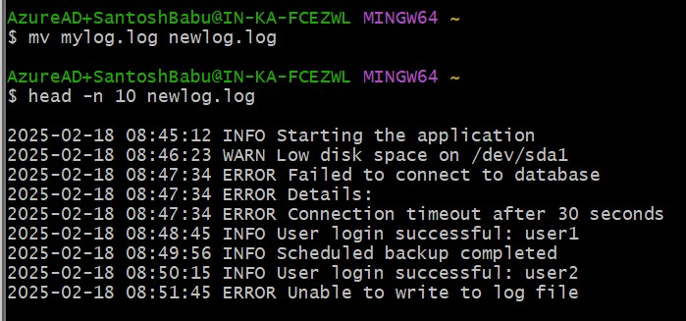

1. Edit the log file and add the string "hello, world!" at the beginning of the file.

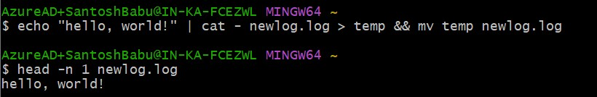

1. Delete the old log file.

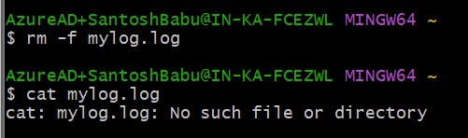

1. Filter entries containing the "INFO" string for a particular date for a given log file, you can use the sample log file given below.

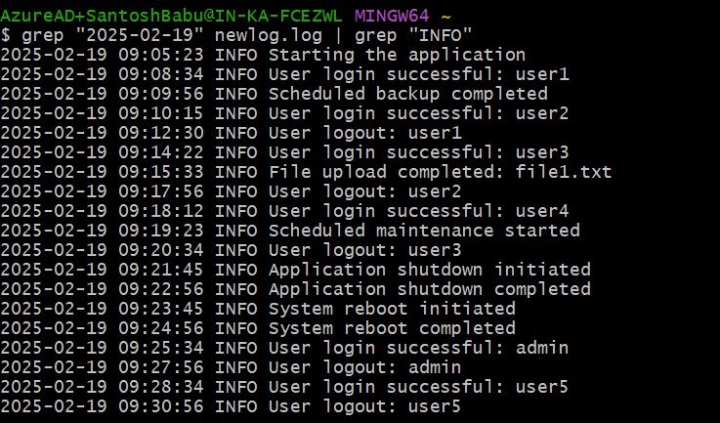

13. Write a command to continuously monitor what is being appended to the file and output if you find the string "Error".



14. Connect to google.com and copy the output to a text file.

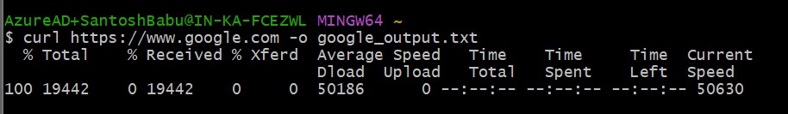

15. Create a file called example.txt. Write a script to make it read-only for all users.

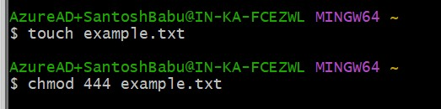

16. Write a script that changes the permissions of a script named myscript.sh to make it executable by the owner, group, and others.

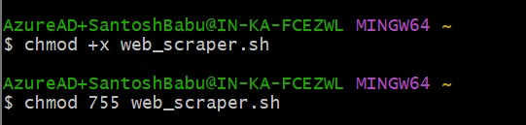

17. Recursively make all the files readable in a directory.

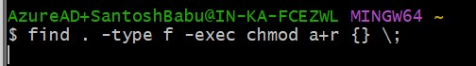

18. List out all the files that end with ".log" in a directory.

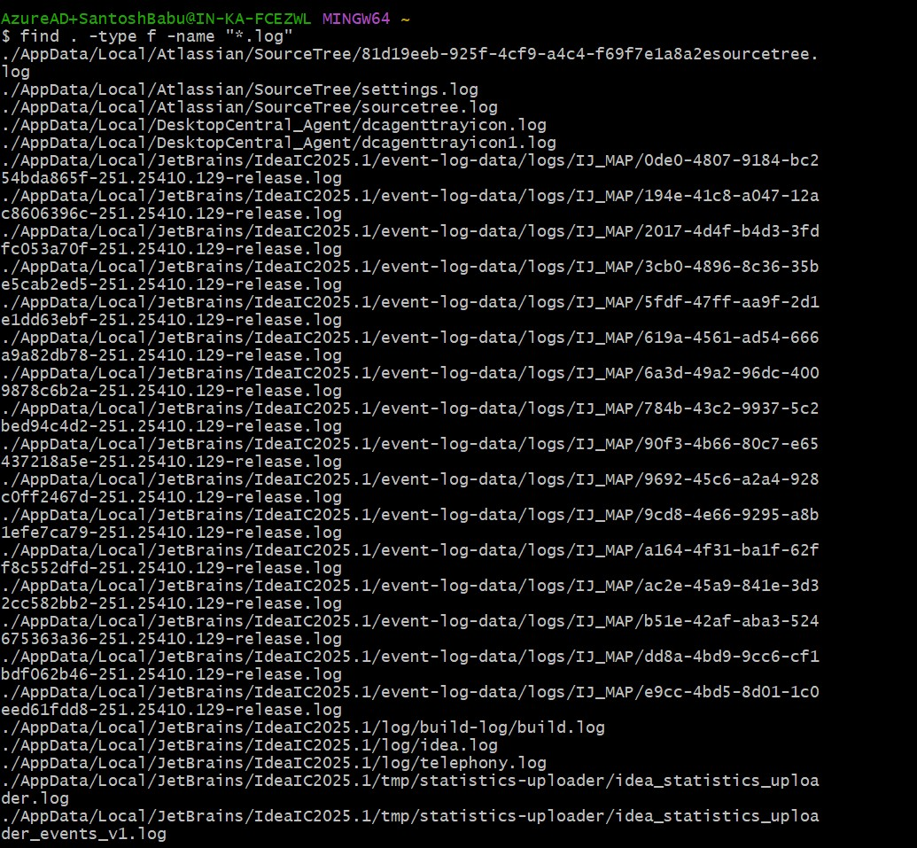

19. Write a command to get the kernel version.

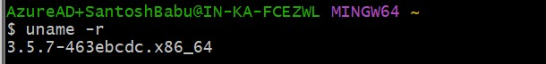

20. Find the IP address of the system.

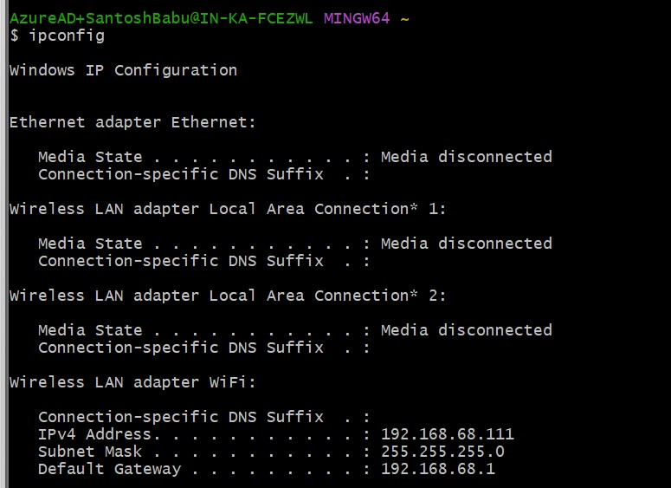

21. Write a script to list all files and directories in the current directory, sorted by size.

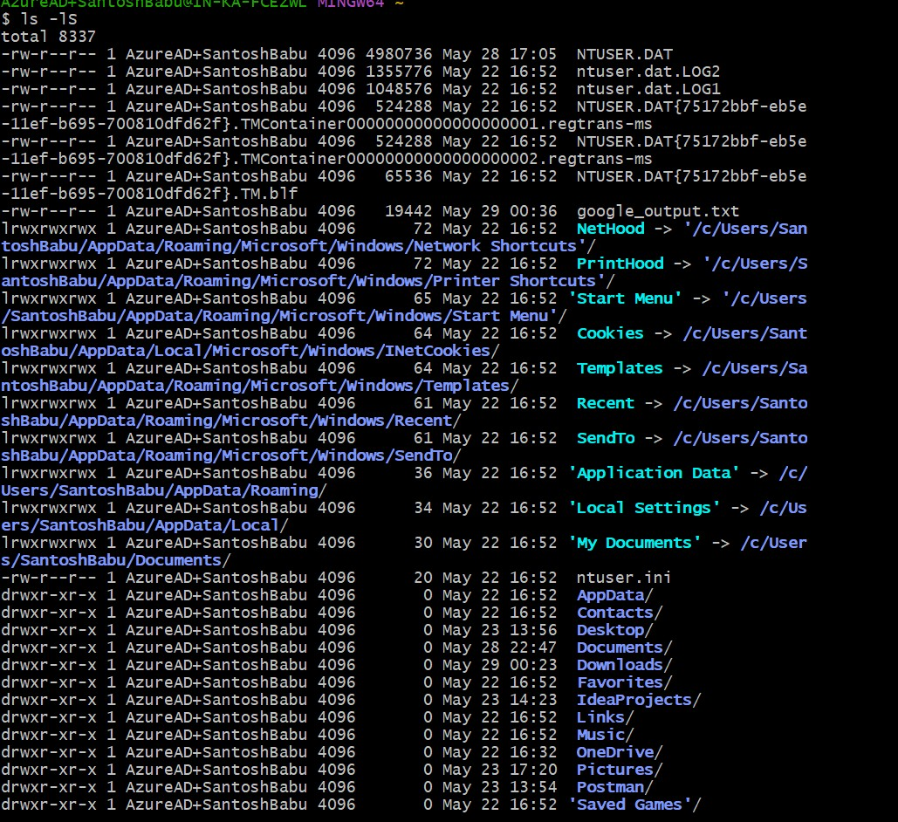

22. List all files and directories in the current directory with sizes in human-readable format.

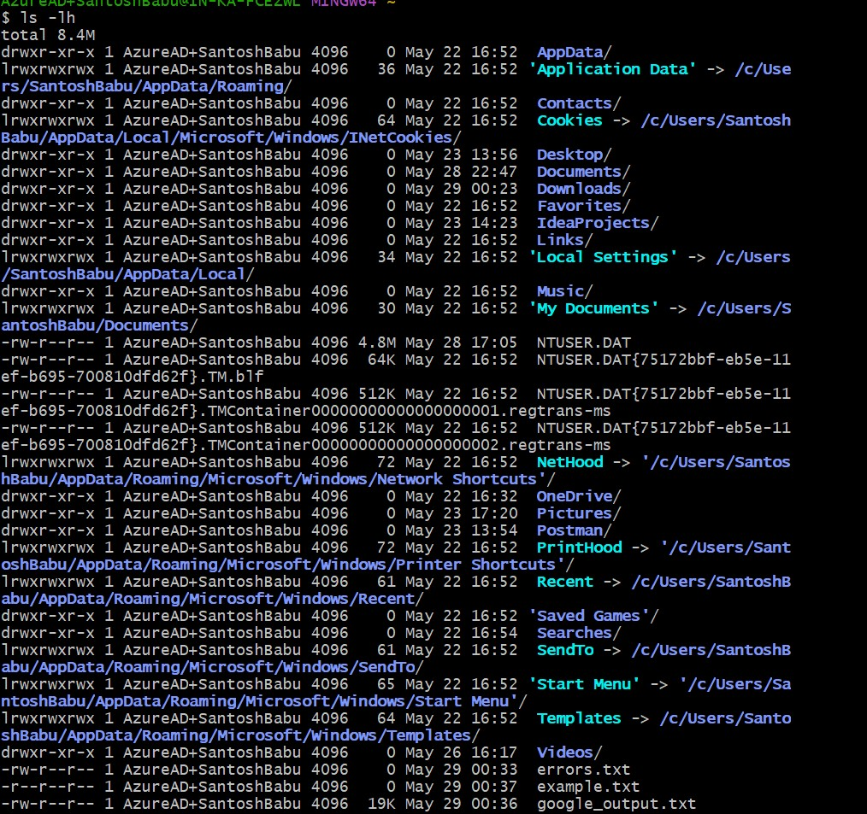

23. Print the hostname a computer.

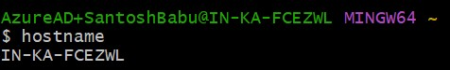

24. Command to Kill a particular process running in your system.



25. Create two files test1.txt and test2.txt with some content and merge it to a single file test.text

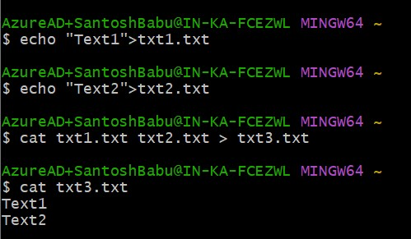

26. Create a shell script test.sh with the content given at the bottom and execute it.

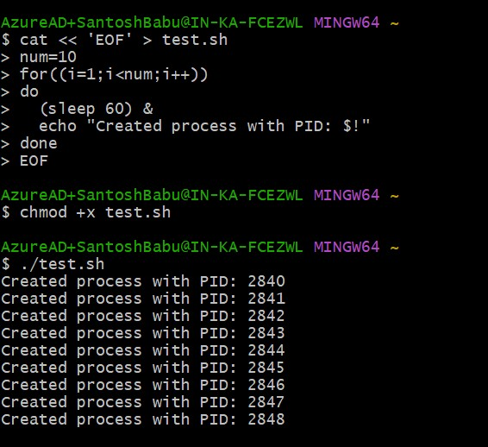

27. Test.sh creates mutiple process , wrtie command to kill some specific process with given pid.



28. Write a shell script which take your name as input and it will dispaly Hello your name.

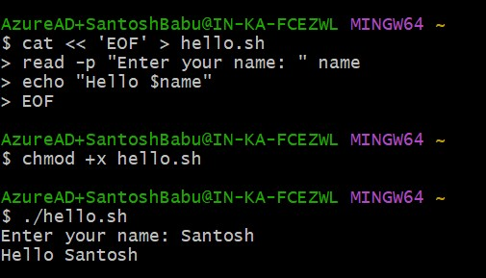

29. Write a command to download file.zip from

<https://github.com/github/gitignore/archive/refs/heads/main.zip>

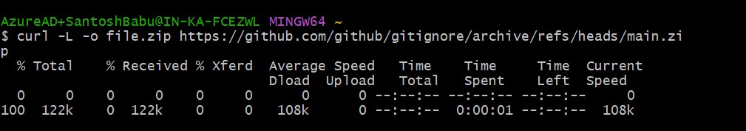

30. Write a command to zip test.txt to test.zip and unzip it.

